Class 2 – Probability Theory
Probability, Conditional Probability, Bayes’ Rule

1. Introduction

2. Some key probability concepts

3. Bayes’ rule

4. Application: Should women in their 40s have regular mammograms?

5. Actionable Items

6. Appendix: Natural Frequencies vs Probabilities in the Mammogram Example

Introduction
Key lesson from last class:

The objective of statistical inference can be summarized as follows: making an inference about a population based on information contained in a sample (drawn from that population) and providing an associated measure of “goodness” for the inference.

So why are we studying probability theory?

Some key probability concepts

Conditional probability

The conditional probability of an event A, given that an event B has occurred, is equal to

$P\left(A | B\right)= \frac{P(A∩B)}{P(B)}$ provided that$P(B)>0$

This is a key concept in statistics. Along with conditional expectation, it provides the basic conceptual underpinnings of regression analysis. More on this coming later in the course.

Independence of Events
If learning that B has occurred does not change the probability of A, then we say that A and B are independent.

Two events are independent if

$P(A∩B)= P\left(A\right)P(B)$

If $P\left(A\right)>0$ and $P\left(B\right)>0$ then A and B are independent if and only if:

$P\left(A | B\right)= P(A)$

$P\left(B | A\right)= P(B)$

The Multiplicative Law of Probability
$$P\left(A∩B\right)= P\left(B∩A\right)=P\left(A\right)P(B|A) = P\left(B\right)P(A|B)$$

The Additive Law of Probability
$$P\left(A∪B\right)= P\left(A\right)+P\left(B\right)-P(A∩B)$$

Law of Total Probability
Assume that $\left\{A_{1},A_{2},…, A_{k}\right\}$ { } is a partition of S such that $P\left(A_{i}\right)>0,$for $i=1,2,…,k.$ Then for any
event $B$,
$$P\left(B\right)=\sum_{i=1}^{k}{P\left(B | A_{i}\right)P(A_{i})}$$
Special case: $P\left(B\right)=P\left(B | A\right)P\left(A\right)+P\left(B\right| \overline{A }) P(\overline{A})$ where $\overline{A}$ is the complement of $A$
Example: $P\left(College\right)= P\left(College \right| Poor) P\left(Poor\right)+ P\left(College \right| NonPoor) P(NonPoor)$

Bayes’ rule
Bayes’ rule provides an extremely useful application of conditional probabilities whereby knowledge that event B has occurred is used to revise (update) the probability that event A has occurred.

If A and B are two events with $P\left(A\right)>0$and $P(B)>0$ then
$$P\left(A | B\right)=\frac{P\left(A∩B\right)}{P\left(B\right)}$$

$$P\left(A | B\right)=\frac{P\left(B | A\right)P(A)}{P(B)}$$

$$P\left(A | B\right)=\frac{P\left(B | A\right)P(A)}{P\left(B | A\right)P\left(A\right)+P\left(B | \overline{A}\right)P(\overline{A})}$$

We can generalize Bayes’ rule to allow for several possible mutually exclusive outcomes

Bayes’ Rule

Assume that $\{A_{1},A_{2},…,A_{k}\}$ is a partition of S such that $P\left(A_{i}\right)>0$, for $i=1,2,…,k$. Then for any event for which

$P\left(A_{j} | B\right)=\frac{P(B|A_{j})P(A_{j})}{\sum_{i=1}^{k}{P(B|A_{i})P(A_{i})}}$

Key ideas:
- In simple terms, Bayes’ Rule provides us with a framework that allows us to calculate P(A|B) when we are given P(B|A)
- This is important because in many real-world situations, we are interested in P(A|B) but the information that is easily available to us is P(B|A)

Application: Should women in their 40s have regular mammograms?
A careful reading of the assigned article reveals the debate to be partly due to differences in analysis and interpretation of empirical evidence, and partly due to differences in the values placed on outcomes. Here, we focus on one empirical issue -- the accuracy of mammograms in detecting breast cancer.

Terminology of medical tests:
 |  | Cancer
 |  | Yes | No
Mammogram | Positive | True Positive | False Positive
 | Negative | False Negative | True Negative

What are the key advantages of recommending mammograms for women in their 40s?

What are the key disadvantages of recommending mammograms for women in their 40s?

Example
- We can formalize two aspects of the accuracy of mammograms:
  - Proportion of those with breast cancer who test positive is 90%
  - Proportion of those without breast cancer who test negative is 95%
- We also know that 1% of women 40-50 have breast cancer

Suppose a randomly drawn woman in her 40s had a mammogram that reported she has cancer. How do you denote the likelihood that the patient indeed has cancer?
- $P(+|Cancer)$
- $P(-|Cancer)$
- $P(Cancer|+)$
- $P(Cancer|-)$
- I don’t know

How do we translate the information given into probabilities?

90% =

95% =
1% =
In general, we would like to know how informative the test is. We would actually like to know the likelihood of false positives and negatives. More specifically, we would like to know:
$$P(Cancer |+)$$ | GOOD: Procedure could save lives
$$P\left(Cancer \right|-)$$ | BAD: Missed opportunity
$$P\left(\sim Cancer | +\right)$$ | BAD: Unnecessary costly procedure
$$P\left(\sim Cancer \right|-)$$ | GOOD: No procedure needed

- We want to know the probability of cancer given the test results, but what we easily know is the probability of test results given whether one has cancer.
- Bayes rule is a method for determining conditional probabilities in one direction when we know the conditional probabilities in the other direction.

Let’s now calculate P(Cancer |+) using Bayes’ Rule.

What does this result imply in terms of how informative a positive mammogram test result is?

Some additional questions:
- Some health experts recommend mammograms for women aged 50 or over, but not for women under 50. Why do you think this is the case?
- What is the intuition behind the result above?
- How can we communicate in a way that people can have a better chance at understanding the probabilities involved in situations like this one?

Key ideas ABOUT MEDICAL TESTING

- The base rate is the underlying rate of some characteristic in the population of interest, in this case it is the prevalence of cancer.

- Base rate neglect (or base rate fallacy): Ignoring the base rate when drawing conclusions from new information. In this case, ignoring that only a small percent of the population has cancer when interpreting a positive test result.

- Public Health vs. Individual perspective: Your base rate might be different than the overall base rate in the population.

Key Lessons ABOUT PROBABILITY IN TODAY’S CLASS

- Beware of confusing $P\left(Disease | +\right) w$ith $P(+|Disease)$
  - More generally, $P(A|B)≠P\left(B | A\right)$
  - In legal circles, this is called prosecutor’s fallacy. Examples: OJ Simpson and Sally Clark

- Bayes Rule allows you to go from P(A|B) to P(B|A) or vice versa.

- Communicating with counts is more effective than communicating with probabilities.

Meta Lessons
1. The process of incorporating new information into your decision-making is formally called Bayesian Updating. It is a very useful approach in both your personal and professional life.
  - Before you took the test, your probability of cancer was P(Cancer)
  - You learn that the test was positive.
  - You “update” your beliefs to P(Cancer | Test +)
    - “What is my probability of having cancer, given that I tested positive?”
    - Even in non-quantitative situations, this is a useful analytical approach

P(Cancer | Mammogram result)
P(Cancer)
Mammogram

2. Human beings are notoriously bad at estimating and dealing with probabilities
  - Well known biases. Base Rate Neglect is a common one
  - See Kahneman and his collaborators for many other ones.

Actionable Items
- Pre-Class Exercise #3 (due Tuesday)
- Problem set #1 (due Thursday):
  - Venezuelan 2024 Elections; requires use of R
  - Mexico Pensions for the Poor

Appendix: Natural Frequencies vs Probabilities in the Mammogram Example
- In the pre-class exercise, you were asked to calculate P(Cancer|+) given numbers similar to the ones earlier in the handout.
- You were randomized into two groups:
  - Group #1: the background information was presented in terms of natural frequencies
  - Group #2: the background info was presented in probabilities (like in this handout)
- The experiment was similar to ones conducted by David Eddy, former consultant administrator on health care reform, who conducted his experiment with American physicians. It was also similar to a study conducted by Hoffrage and Gigerenzer, who conducted their study with German physicians.
- Both studies reveal that physicians are much better at estimating P(Cancer|+) when the information is presented in natural frequencies than in conditional probabilities. When the information was presented in probabilities, physicians grossly overestimated P(Cancer|+) whereas when it was presented in natural frequencies, physicians were more accurate.
- Here is a possible explanation for why natural frequencies are more intuitive:
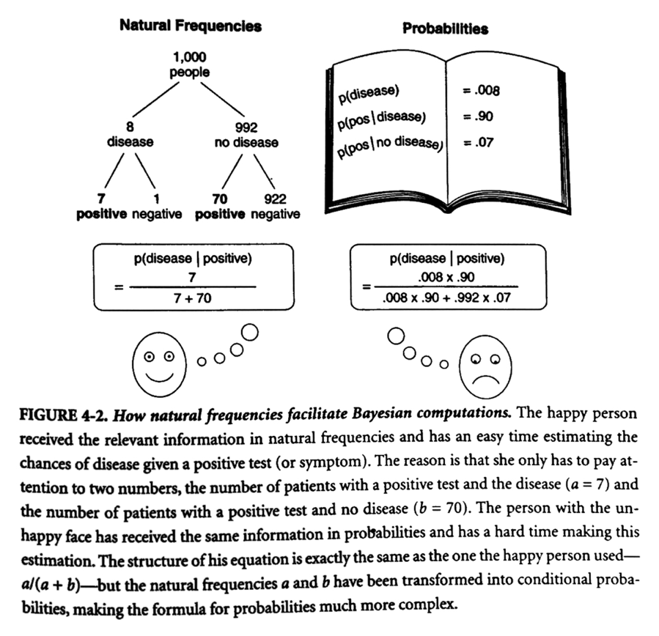
Source: “Calculated Risks: How to know when numbers deceive you” by Gerd Gigerenzer (2002)

A clarifying note: This course will assume a working knowledge of probability theory, as reflected in the math camp material of Prof. Deb Hughes Hallett. The background material column of the course schedule (located in the syllabus) contains the key concepts needed for each class.
In technical terms: estimating a conditional probability while ignoring the underlying marginal probability.
Eddy, D. M. (1982). Probabilistic reasoning in clinical medicine: Problems and opportunities. Source: https://faculty.washington.edu/jmiyamot/p548/eddydm%20prob%20reas%20i%20clin%20medicine.pdf
Hoffrage, U, and Gigerenzer, G (1998) Using natural frequencies to improve diagnostic inferences. Academic Medicine, 73, 538-540. In “Calculated Risks: How to know when numbers deceive you” by Gerd Gigerenzer (2002)

